# Lab 5: How to use Bootstrap, Templates & Themes

# OBJECTIVES:

Student can create a first basic website with Bootstrap class.

* + Write programs in Bootstrap
  + Apply CSS and JavaScript to Bootstrap components

# EXERCISES

* 1. **Create Register.html file with the following interface:**

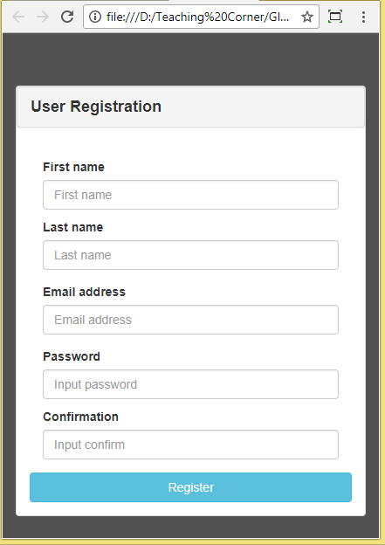

**Figure 1.1**

* **Step 1:** add the following code in head tag

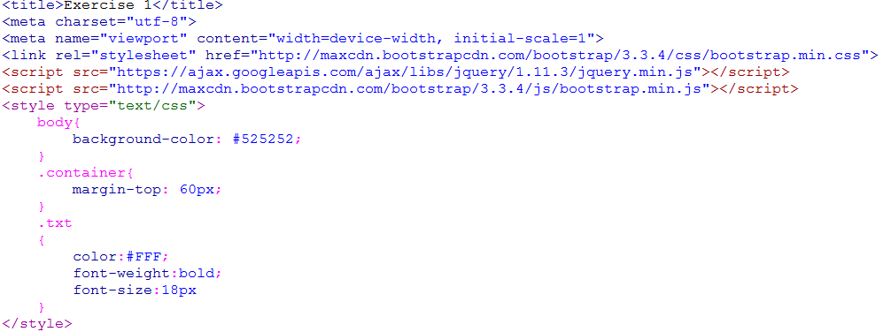

* **Step 2:** Type the following code

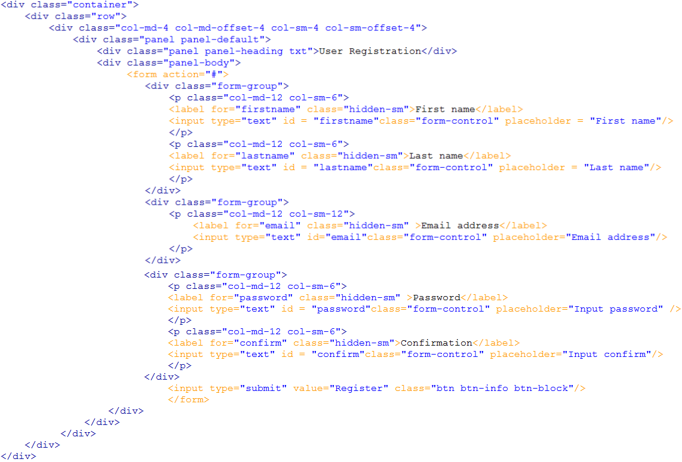

2. Create index page as the follwong picture

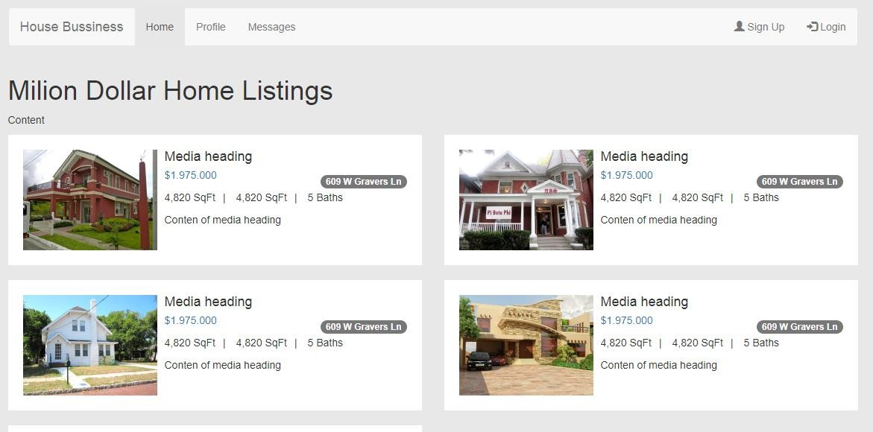

Hint:

# Figure 1.2

